**PRACTICAL NO. 5**

**AIM :** Installation and Configuration of virtualization using KVM.

**SOLUTION :**

**Step 1:** Update your Ubuntu

Command : Sudo apt-get update

**Step 2:** Check if hardware virtualization support is available on a CPU in an Ubuntu system. Type the following command.

Command : egrep -c ‘(vmx|svm)’ /proc/cpuinfo



**Step 3 :** Install cpu-checker

Command : Sudo apt install -y cpu-checker

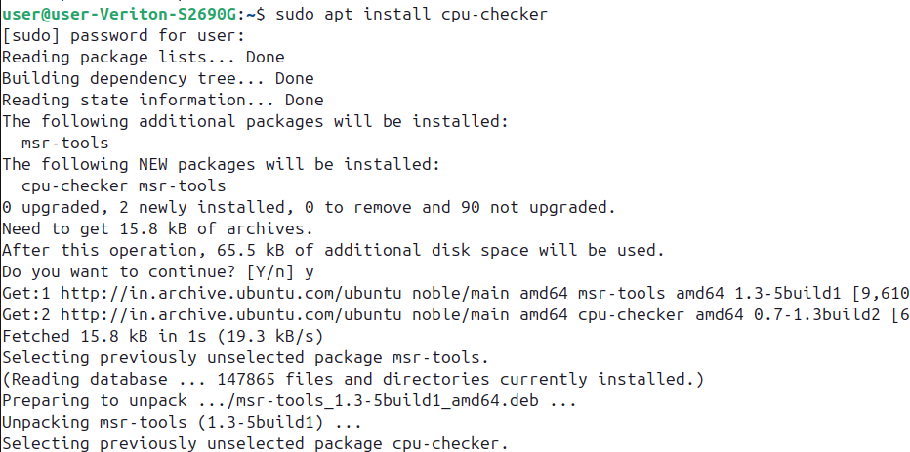

**Step 4:** check if your system supports hardware virtualization and if it is enabled.

Commad : kvm-ok

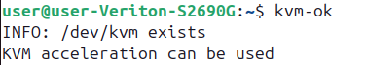

**Step 5:** Install the necessary tools and dependencies for setting up KVM

Command : sudo apt-get install -y qemu-kvm virt-manager libvirt-daemon-system virtinst libvirt-clients bridge-utils

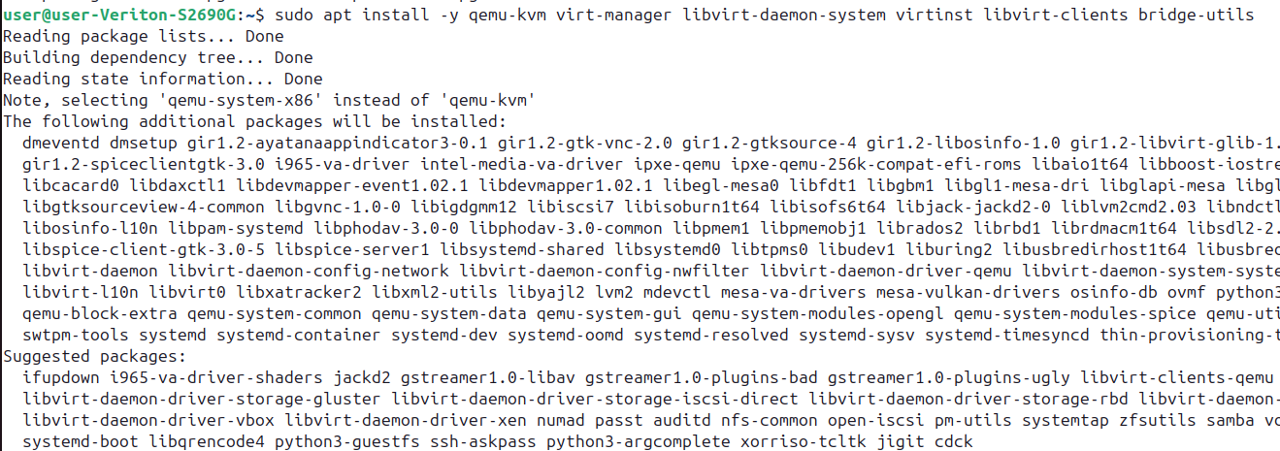

**Step 6:** Enables and starts the libvirtd service at boot for managing KVM virtualization. Checks the current status of the libvirtd service to confirm it is active.

Command : sudo systemctl enable –now libvirtd

sudo systemctl start libvirtd

sudo systemctl status linvirtd

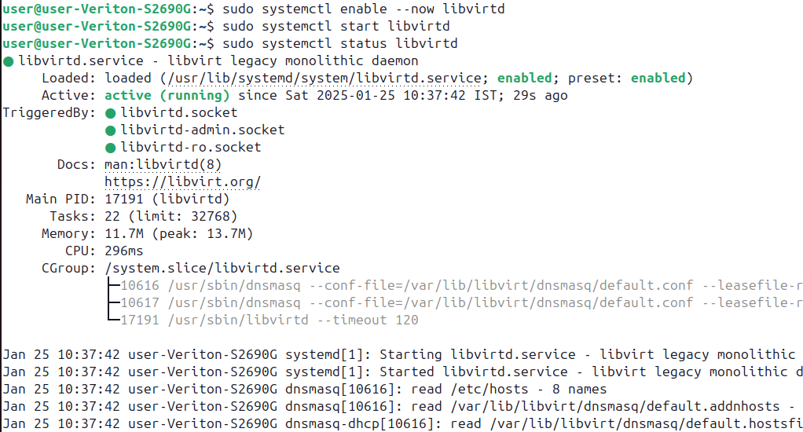

**Step 7:** In this step search virtual machine and start

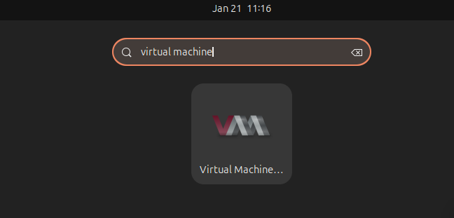

**Step 8:** Click add connection

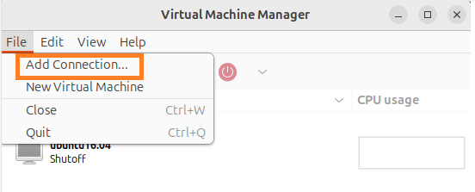

**Step 9:** Now click connect

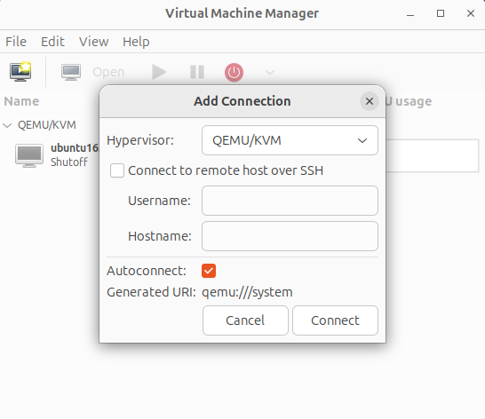

**Step 10 :** The select the computer icon as shown in mage

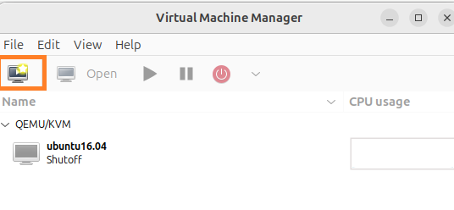

**Step 11 :** Select ‘Local install media’ and Click on Forward

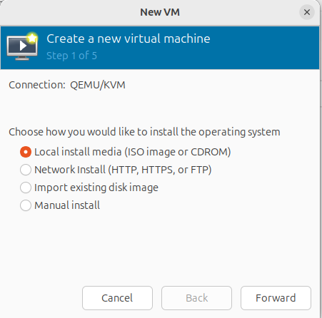

**Step 12:** Select the .iso from Downloads and click on ‘Choose volume’

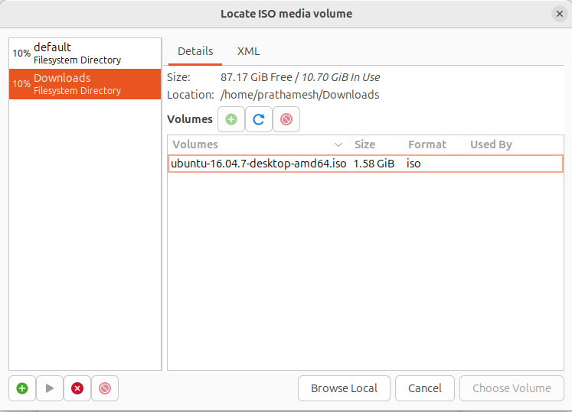

**Step 13 :** Click on ‘Forward’

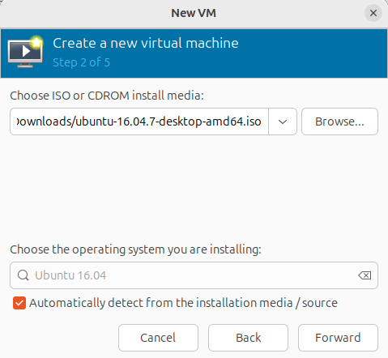

**Step 14 :** Select Memory= 2048 and CPUs = 2 and Click on ‘Forward’

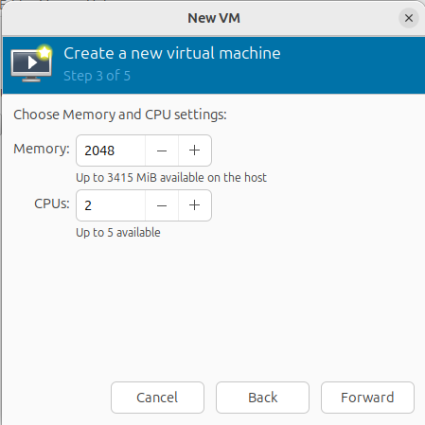

**Step 15:** Click on Radio button and config. The disk image to 15.0 and click on Forward

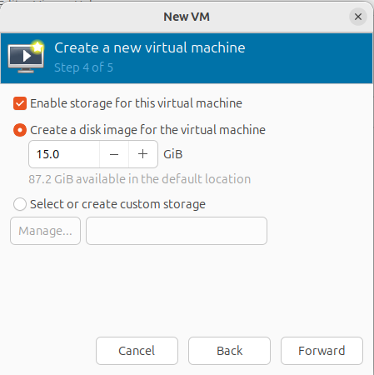

**Step 16 :** Click on ‘Finish’

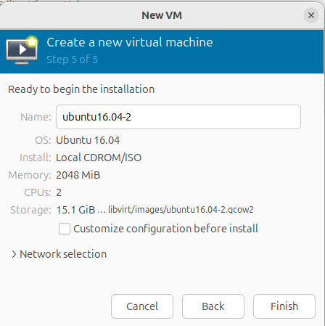

**Step 17 :** The installation has been successfully completed

Select the Language i.e English

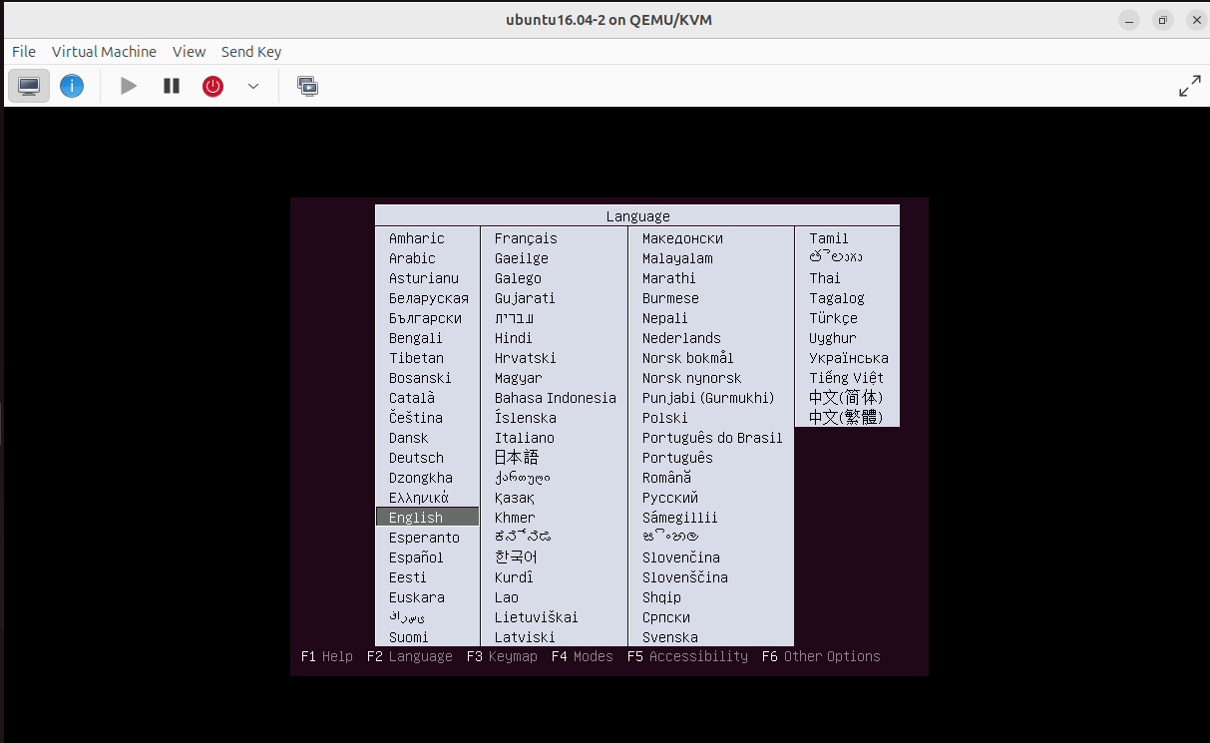

Select second option from arrow key ‘Install Ubuntu’

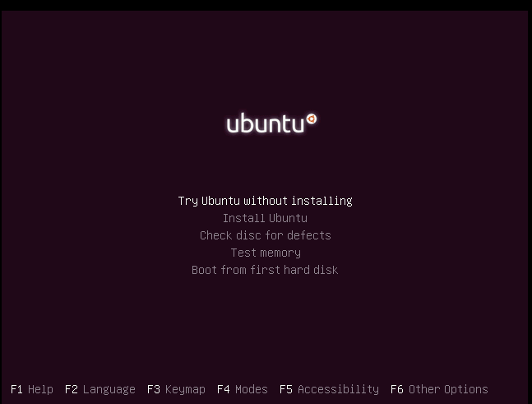

All set and ready to go!